Water Baptism

Water baptism is a public declaration of your commitment to follow Jesus Christ. Baptism represents dying to your self-willed nature— to doing things your own way— and being raised to a new life of obedience to Jesus— doing things His way.

Jesus was Baptized

Read Matthew 3: 13-17.

What does this passage reveal about the high significance God places on baptism?

What was the reason Jesus should be baptized?

Jesus was already righteous, but He fulfilled all righteousness by obeying His Father in the act of baptism. He set an example for all believers to follow: obedience and water baptism.

Your obedient "yes" to water baptism sets the stage for a life of total obedience to Jesus, your Lord.

Jesus Commanded Believers to be Baptized

Shortly before Jesus ascended to His Father in heaven, He gave these instructions to His disciples:

Read Matthew 28: 18-20.

What two things did Jesus say should happen when a person becomes His disciple, or follower?

Three Foundational Truths

Acts 2: 37-38, 41 records the people's response to Peter's first sermon. When the people heard this, they were cut to the heart and said to Peter and the other apostles, "Brothers, what shall we do?" Peter replied, "Repent and be baptized, every one of you, in the name of Jesus Christ for the forgiveness of your sins. And you will receive the gift of the Holy Spirit..." Those who accepted his message were baptized, and about three thousand were added to their number that day.

Peter gives three foundational truths upon which the Christian life is built. List them below.

1. ___________________________________________________
2. ___________________________________________________
3. ___________________________________________________
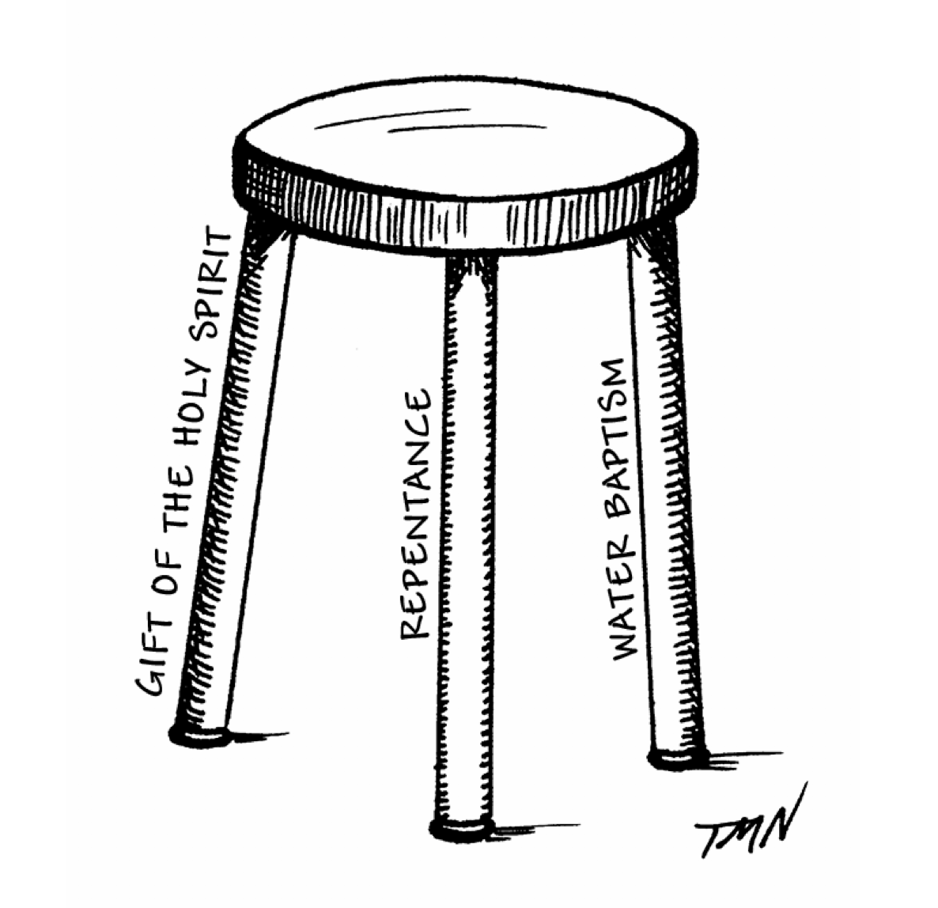
Like three legs of a stool, these three truths (repentance, water baptism, and receiving the gift of the Holy Spirit) provide a strong foundation for your walk with Christ. The stool won't stand if any leg is missing.

Repentance is asking God's forgiveness for your sins (wrongdoings) and turning from them. Sin is doing things your way instead of God's way. It's an attitude of active rebellion or passive indifference toward God and what He wants in your life. Repentance must always precede baptism. If you have not repented— turned from your own way to God's way— then being baptized in water will serve no purpose. The physical act of baptism does not save you. (Learn more in the Tools for Mentoring module "Repentance and Making a Moral Inventory.")

Water baptism is an outward action that testifies of an inner change of life, a change that is initiated by repentance and developed through ongoing obedience to Christ as His follower.

Receiving the gift of the Holy Spirit helps you walk in His power every day. Learn more in the Tools for Mentoring module "The Baptism with the Holy Spirit."

Believe and Be Baptized: The Example of the First Century Believers

When you repent of your wrongdoings and decide to follow Jesus, you can be baptized right away.

To be baptized in the name of Jesus Christ means that you accept and identify with Christ's sacrifice on your behalf. You declare the end of all efforts to earn your way to heaven by being good enough.

Look up these passages from the book of Acts. What happened regarding water baptism?

Acts 8: 12-13
Acts 8: 26-40
Acts 9: 17-19 (verses 1-19 for the context)
Acts 10: 44-48 (verses 9-48 for context)
Acts 16: 29-34 (verses 23-34 for the context) Acts 18: 8
Acts 19: 1-7

Baptism Illustrates a Spiritual Reality

When Christ died on the cross, He paid for the forgiveness of your sins— your God-resisting, independent self-will and all the wrong things you did as a result. He also paid for your freedom from being ruled or mastered by sin any longer. When you repented, you accessed that forgiveness and that freedom. Baptism shows how that happened. What shall we say, then? Shall we go on sinning so that grace may increase? By no means! We are those who have died to sin; how can we live in it any longer? Or don't you know that all of us who were baptized into Christ Jesus were baptized into his death? We were therefore buried with him through baptism into death in order that, just as Christ was raised from the dead through the glory of the Father, we too may live a new life. Romans 6: 1-4.

To "baptize" means to immerse something into a liquid. You are immersed into Christ. What happened to Christ, happened to you. When He died and was buried, your old way of living, the self-willed, sin-ruled life, died with Him. What do you do with a dead body? You bury it! The first part of water baptism illustrates the burial of the "old self." For we know that our old [self-willed, sin-ruled] self was crucified with him so that the body ruled by sin might be done away with, that we should no longer be slaves to sin... Romans 6: 6

When Jesus was raised from the dead, you were raised with Him to a new life. The second part of water baptism— coming out of the water— illustrates your resurrection as a new person. You come out of the water with the freedom to live a new life of righteousness, not by your own strength, but by God's resurrection power! Now if we [the self-willed, sin-ruled self] died with Christ, we believe that we will also live with him [new life ruled by God]. The death he died, he died to sin once for all; but the life he lives, he lives to God. In the same way, count [consider or realize] yourselves dead to sin but alive to God in Christ Jesus. Romans 6: 8, 10-11 (emphasis added)

When He was resurrected by the power of the Holy Spirit, a new you was resurrected— a you that is no longer ruled by sin unless you allow it by your choices. Therefore do not let sin reign [rule] in your mortal body so that you obey its evil desires. Do not offer any part of yourself to sin as an instrument of wickedness, but rather offer yourselves to God as those who have been brought from death to life; and offer every part of yourself to him as an instrument of righteousness. For sin shall no longer be your master, because you are not under the law, but under grace [Christ's pardon and power to do what is right] Romans 6: 12-14 (emphasis added)

Do You Need to be Baptized to Have Salvation?

There are no actions you can perform to add any value to Christ's death, which fully atones for your wrongdoing. You are saved by believing His payment is fully sufficient for your forgiveness— no additional good works justify you before God. For it is by grace you have been saved, through faith— and this is not from yourselves, it is the gift of God— not by works, so that no one can boast. Ephesians 2: 8-9 Your grateful response to Jesus' gift is to follow Him in obedience; follow Jesus in water baptism.

What If You Sin After You Are Baptized?

According to Romans 6: 13, the rest of your life is a process of offering yourself more to God's liberating rule and less to sin's slavery. Do not offer any part of yourself to sin... but rather offer ... every part of yourself to him as an instrument of righteousness. You have the freedom to become an instrument of righteousness, since the slavery to sin was buried with Christ and you now live in the new resurrection life with Him.

Baptism demonstrates this spiritual truth. You bury your sin-ruled, self-willed nature and your good intentions in the watery grave of baptism. You are resurrected out of the baptismal grave relying on His resurrection power to help you do what is right.

Therefore, if you sin, ... we have one who speaks to the Father in our defense— Jesus Christ, the Righteous One. He is the atoning sacrifice for our sins, and not only for ours but also for the sins of the whole world. If we confess our sins, he is faithful and just and will forgive us our sins and purify us from all unrighteousness. 1 John 2: 1-2 and 1: 9

When the Holy Spirit shows you sin in your life, repent quickly and accept His forgiveness. Then offer yourself again to God as an instrument of right living. Do the next right thing He tells you in the Bible or by the Holy Spirit's inner voice (an impression or "hitch"). He might say, "Don't go to that bar," "Stay away from that person," or "Block that website." Lean on His strength to obey; don't depend on your own. Walking with Jesus is daily offering yourself more to Him and less to sin. (See Tools for Mentoring module "Overcoming Sin.")

Preparation for Water Baptism

Please answer the following questions:
- Have you repented of your sins?
- Do you believe that Jesus' death and resurrection fully paid for the forgiveness of your sins?
- Do your confess Jesus Christ as your Lord and Savior?
- Do you renounce Satan and all his works and all his ways?
- Do you promise to follow Jesus Christ and be faithful to Him until He returns for you?

What If You Were Baptized as an Infant?

Repentance and faith in Jesus' atonement for sins is a prerequisite for baptism. Jesus' instructions specify belief in Him and then baptism: Therefore go and make disciples of all nations, baptizing them in the name of the Father and of the Son and of the Holy Spirit... Matthew 28: 19 The book of Acts describes those who confess faith in Jesus being baptized, sometimes along with their believing households (See "The Example of the First-Century Believers."). Since a baby is incapable of volitional belief, infant baptism should be seen as an act of the parents' faith to dedicate their child to God.

If your parents had you baptized as an infant, God remembers their faith and the prayers prayed for you at the time. Now, as an adult, water baptism is a public declaration of your repentance, your faith that Christ's sacrifice washes away your sins, and your decision to follow Him. It is not a rejection of what your parents did for you; it is ratifying their faith and making it your own.

Schroeder, Joy. Tools for Mentoring: Complete Volume. Father Heart Ministries, Inc.. Kindle Edition.

